SCHOOL BASED ASSESMENT

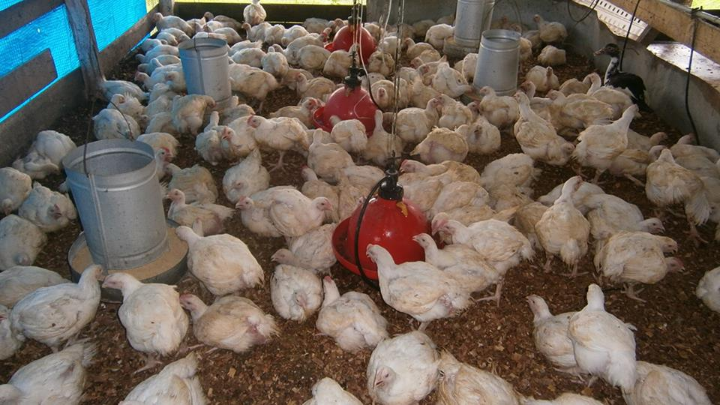

Name of Candidate: Euclid Nedd

Candidate Number: ---------------------

Centre Number: ---------------------

Territory: Guyana

Subject: Agriculture Science

Teacher: MS.B.Araham

Production of Eggs

COST ANALYSIS

**Name of project:** Egg production

**Location:** Sophia Practical Institution Centre (S.P.I.C.)

**Duration:** 54 weeks

Description of Activities

Preparation of Pen

Addition of Litter

Feeding

Debeaking

Construction of perches

Construction of nest boxes

Collecting Eggs

Sorting Eggs

Grading Eggs

Marketing of Eggs

Selling/Culling of Layout Birds

**Materials and equipment**:

Record sheets, egg baskets, egg crates, Broom, Bucket, Detergent, Shavings

**Schedule of operation:**

|  |  |  |
| --- | --- | --- |
| Week | Activity | Remarks/Observation |
| 1 | Clean and disinfect pen | The pen should be cleaned at timed intervals and when there is too much litter. |
| 2 | Preparation of Brooder | The brooder should be circular so that the birds do not die while crowding in a corner. |
| 3 | Introduction of Layers | The birds should be carefully placed in the brooder. |
| 3-54 | Feeding, Watering | This should be supplied regularly. |
| 4 | Debeaking | This should be done to prevent cannibalism. |
| 8 | Construction of perches | The perch should not be built too high because the bird may experience injuries if it experienced falling. |
| 16 | Construction of nest boxes | These should be made large enough to fit many eggs. |
| 18-54 | Collection, Sorting, Grading, Marketing of eggs | This stage should be carefully done so as to realize the amount of bad eggs and get rid of them. |
| 54 | Culling of layout birds | The birds should be culled so that they can be sold and earn income. |

Projected Income

|  |  |
| --- | --- |
| Layers | 100 |
| Expected Egg Production | 87% |
| Price | $38 |
| Duration | 1 week/7 days |
| Total Income Weekly | $23142 |
| Total Egg Production Income | $1249668 |
| 90 Layout Birds@$480 | $43200 |
| 55 bags pen manure@$310 | $17050 |
| Total Projected Income | $1309918 |

Projected Expenditure

|  |  |
| --- | --- |
| 100 pullets@$350 | 35000 |
| 10bags chick starter@5500  10bags Pullet grower@5600  108bags egg ration@5500 | $55000  $56000  $594000 |
| 1096 egg trays@$30 | $32880 |
| 23bags wood shaving@$120 | $2760 |
| 1gal jeyes fluid | $4040 |
| 3pks Antibiotic@$700 | $2400 |
| 10Egg Booster@$600 | $6000 |
| 1Perch | $5000 |
| 1Nest Box | $20000 |
| 6 Bulbs@$500 | $3000 |
| 182kw electricity@$58 | $10556 |
| 550hrs Labour @$200 | $55000 |
| Transportation | $54000 |
| 1 1”sponge | $3000 |
| Miscellaneous | $35000 |
| Total Projected Expenditure | $973636 |

Projected Surplus

|  |  |
| --- | --- |
| Total Projected Income | $1309918 |
| -Total Projected Expenditure | -$973636 |
| Profit | $336282 |

Actual Income

|  |  |
| --- | --- |
| Egg Production | 93% |
| Price | $33 |
| Duration | 1 week/7 days |
| Total Income Weekly | $21483 |
| Total Egg Production Income | $1160082 |
| 93 Layouts@$360 | $33480 |
| Total Actual Income | $1193562 |

Actual Expenditure

|  |  |
| --- | --- |
| 100 Pullets@$330 | $33000 |
| 10 bags chick starter@$5900 | $59000 |
| 10 bags pullet grower@$5800 | $58000 |
| 108 bags egg ration@$5700 | $615600 |
| 1172 egg trays@$25 | $29300 |
| 25 bags wood shaving@$200 | $5000 |
| 1 gal jeyes fluid | $4060 |
| 3pk antibiotic@$800 | $2400 |
| 10pk egg booster @$600 | $6000 |
| 6 Bulbs @$125 | $740 |
| Transportation @$1000 | $54000 |
| Total expenditure | $867110 |

Actual Surplus :

|  |  |
| --- | --- |
| Actual Income | $1193562 |
| -Actual Expenditure | -$867110 |
| Profit | $326452 |

Analysis :

The projected and actual incomes were examined to be $1309918 and $1193562 correspondingly. Their difference was $116356.This was so because the layout birds were sold for $120 more than the actual.

The projected expenditure was $973636, whereas the actual expenditure was $867110. With a difference of $106526 this is so because the researcher had to pay more items and these cost were not included on the actual expenditure, also expenses in the actual expenditure were much higher than those of the projected expenditure.

The projected surplus which was $336282was higher than the actual surplus which was $326452, with a difference of $9832, this is a result of the vast difference in the expenditures and incomes.

General Comments :

A layer is a bird that are reared for their precious eggs. The production of these egg yielding birds was a fun and educational experience. These birds are vulnerable to disease and require good sanitation. The birds should be constantly fed and supplied with water. The collection of the bird’s eggs should be scheduled so that the birds would not crack eggs that are not collected. Layout birds when ready to be marketed should be weighed to see if their weight is at the required pounds. They should then be slaughtered and dressed to be sold.

Conclusion :

It can be concluded that the researcher had learnt to clean, grade, and pack eggs correctly. Also it was learnt that a perch is made for the birds to sleep on.

Recommendations :

It can be suggested that:

* More feed should be provided
* Proper sanitation is urgently needed
* Egg collection should be scheduled properly
* Layers should have more space in their brooder.